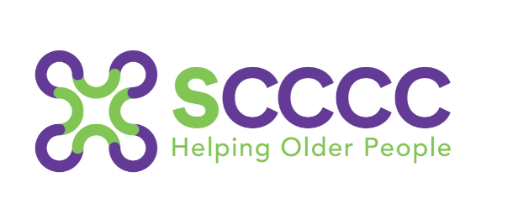

Good Neighbour Scheme referral form
Referrer to complete

Date: Time:
Personal information
Client name

Client address

Contact telephone numbers
Email address
Any other contact methods used?
(WhatsApp/Zoom)
Date of birth
Age
Gender
Ethnicity
Community Language and country of birth
(if happy to share and relevant to a match)
Smoker?
If yes, have you visited the property?
Please note: If the client is a heavy smoker and/or the home has a strong, smoky residual odour, we will be unlikely to be able to send a staff member or volunteer to do face to face visits.
Any pets?
Please give details
Have you met them?
Please detail behaviour or any concerns.
Key safe? Location/code
Are there any monitoring devices in the service users' home (Cameras etc.)

Does the patient give their consent for us to keep their details and to contact them regarding our services?
Can we contact them directly?
What services would they be interested in?
(Friendly visits/Telephone calls/Penpals)
Please note: We do have a wait in some areas for face-to-face volunteers (we are constantly recruiting), we keep in touch with people waiting and can offer telephone support and the penpal scheme in the meantime if appropriate.
Any impairments or long-term illnesses? Please consider:
- Hearing | - Memory/Dementia
- Eyesight | - Long standing illness
- Disability | - Mental Health
- Palliative | - End of life
- Mobility

Please note: If the client has Dementia; are they able to communicate effectively and hold a conversation for up to 30 minutes? Will a new person be able to visit them at home without causing any confusion or distress?
If not, the service may not be appropriate, please call us if you would like to discuss further.
Does the client have a DNAR in place?
If any mental health or Dementia diagnosis, please give details of any professional contacts working with client currently.
Are there any safety concerns of any kind we would need to be aware of?
Which GP the client is registered with?
Does the client live alone?
Background information
(Hobbies/previous work/situation)
(Family and friend support?)
Has the client ever been in the services? (Armed Forces / Navy / RAF)
Next of kin/Contact person
NOK contact telephone number
Does the client have a care package?
Which care company?
How many visits per day?
What are they helping the client with?
Who does the client’s shopping and cleaning?

Referrer full name

Job Title and Department
Contact telephone number
Email address
(We may email to ask for feedback.)
Location/base

Any other relevant information?

Thank you for referring to the Good Neighbour Scheme. When completed, please email this form to scccc.referrals@nhs.net Any referral forms not coming from a secure email inbox, please password protect the document and send the password in a separate email.
If we require any further information we will be in touch. If you need to contact us, please call 0114 2505290 – Option 2

