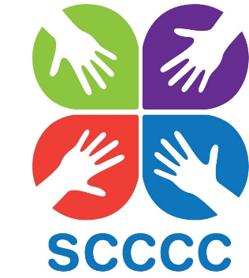

I am abseiling down the side of the Owen Building at Sheffield Hallam University on Saturday 11th May 2019.

Sheffield Churches Council for Community Care is a charity that provides a helping hand to older and vulnerable people
when they need it most. Working closely with the statutory agencies in Sheffield we provide a network of support for mainly
older people who may have nobody else to turn to for practical or friendly support.

Through your generous sponsorship we can, together, achieve our vision of “…where lives are positively transformed, needs are met and loneliness eradicated”

Name
Address

Please help me to make a difference by sponsoring me today
Please Gift Aid your donation so we can claim Gift Aid tax relief of 25p for every pound you give – at no extra cost to you. Just tick the box on your sponsorship line and don’t forget to give your full home address and postcode.

If you have ticked the box headed ‘Gift Aid? ’, I confirm that I am a UK Income or Capital Gains taxpayer. I have read this statement and want the charity or CASC named above to reclaim tax on the donation detailed below, given on the date shown.

I understand that if I pay less Income Tax / or Capital Gains Tax in the current tax year than the amount of Gift Aid claimed on all of my donations it is my responsibility to pay any difference. I understand the charity will reclaim 25p of tax on every £1 given.

Full Name | Home Address  (please give your full address or we can’t claim Gift Aid) | Postcode  (essential for Gift Aid) | Gift Aid? | Amount paid | Tick if you don’t want to hear more about SCCCC
Ms A Sample | 1 Sample St, Sample Town | SM1 1SM |  | £10.00
 |  | Subtotal (this page) |  | £
 |  | Subtotal (other pages) |  | £
 |  | GRAND TOTAL |  | £
 | Date money sent to SCCCC:
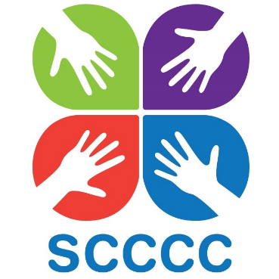

Sponsorship form (continued)
Please help me to make a difference by sponsoring me today

Name
Address

Full Name | Home Address  (please give your full address or we can’t claim Gift Aid) | Postcode  (essential for Gift Aid) | Gift Aid? | Amount paid | Tick if you don’t want to hear more about SCCCC
Ms A Sample | 1 Sample St, Sample Town | SM1 1SM |  | £10.00
 |  | Subtotal (this page) |  | £

How to get the money to us
Once you have finished your event and collected your sponsorship money you can:
1. Pay via our website at www.scccc.co.uk
2. Make an online transfer to our bank account: Unity Trust Bank, Account No: 20373636, Sort Code: 60-83-01
Please include REF: your name so we know it’s from you!
3. Send a cheque for the full amount made payable to SCCCC to Unit 19, President Buildings, Savile Street East, SHEFFIELD, S4 7UQ

Please ensure that all donations collected offline (cash and cheques) are given to Sheffield Churches Council for Community Care in the form of one cheque or payment per participant.

If you have any queries please get in touch: ericka.hill@scccc.co.uk

